Initial Document

# Support Tickets Database Manger

**A support ticket** is a service request from a user that is received by a ticketing system. A support ticket is generated once a user approaches a support organization. The support ticket can be filled in various ways, by the customer or via a support reprehensive.

The ticket enables the following functions:

1. Identify the user (contact details) via a contact person form
2. Identify the type of the problem
3. Identify the severity of the issue
4. Get a short description of the problem
5. Provide a status regarding the stage of the issue (In process, escalated, closed and more)
6. Will provide a status regarding the stakeholder who are involved in various ways in the specific instance
7. All tickets are saved within the ticketing database system
8. Customer’s history can be tracked
9. Support the workflow

The process of managing, sorting, and filtering through the Ticketing database can quickly become a burden. Many different bodies need to be able to provide their input on any given support issue before the instance can be closed. A lot of knowledge is involved that can be analyzed for the sake of improving the support system

Therefore, a decision was made to create a system that will manage the whole tickets.

A Ticket generally should include (but not limited to) the following sections:

1. User’s contact details
2. Status of the instant
3. Type of the instant
4. A short description of the instance
5. Tags
6. Owner of the instance
7. Notes of action taken in every step

**Requirements**

1. Tickets should be organized based on verity of parameters e.g. user type etc.
2. Tickets should be able to securely storeed into the ticket cv database
3. Tickets should be sorted based upon status
4. A ticket template should be created
5. A contact template should eb created
6. Contact should be linked to tickets
7. A ticket should contain all the history of a specific instance
8. A reporting system for the sake of analysis
9. More!!

**Hackathon Goals**

    •    Complete a working prototype of the program that will provide the customer with a visual understanding of the end product.

    •    Formally convert the client's initial document into product requirements.

**Examples**

**Ticket**

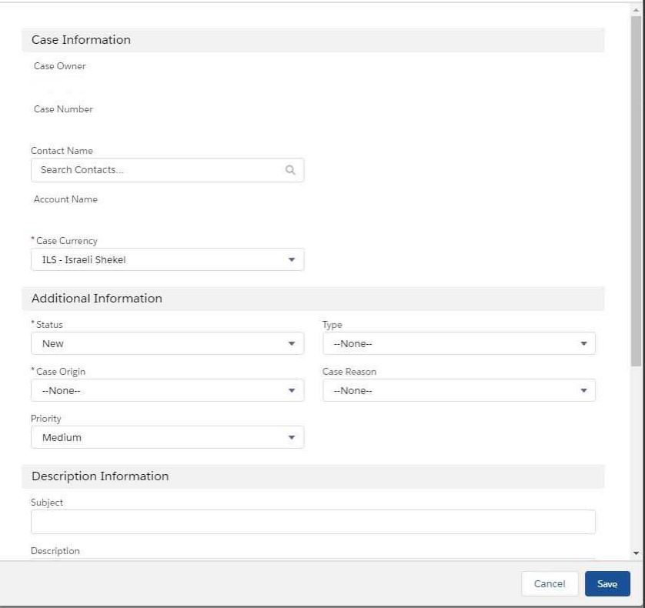

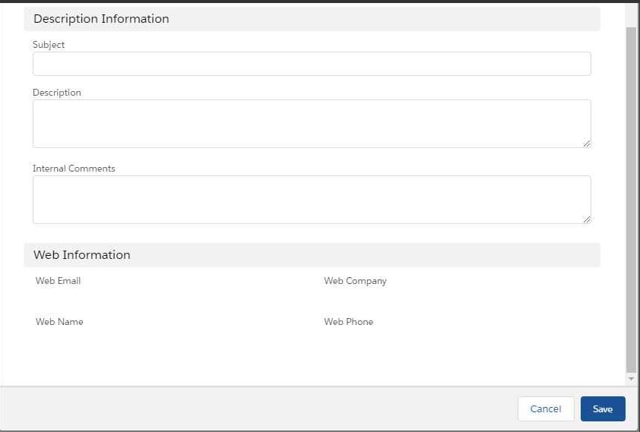

Contact Person example

